**ArcGIS Pro, Python, ArcPy, Pandas, and COD Services API a GIS How To Mashup**

Provided in partnership with UN OCHA, University of Georgia CVIOG ITOS, and USAID

Geographic Information Systems (GIS) tools, datasets and delivery mechanisms are continually evolving to make information flow and support users in decision making and generating new useful products. The ArcGIS Pro environment accommodates this momentum where both data science and GIS practitioners work may be enhanced to support each of these user groups very well where locations are a part of the equation. Data scientists regularly working with Anaconda, Pandas and Jupyter Notebooks may now find them available in a platform well suited to working with GIS data and GIS developers may now leverage the versatility of working in the Notebook platform. Providing a dynamic map visualization that highlights conditions is a common use and the example of humanitarian Common Operational Dataset (COD) availability is a good specific case where the ArcGIS Pro Notebook can be used. The adaptation of Humanitarian Data Exchange (HDX) for specific COD elements with the COD Services API features allows for a concise list of countries and themes available without the need for extra coding and queries on the HDX API to retrieve the appropriate results.

|  |  |
| --- | --- |
| Results | Documentation |
| <https://apps.itos.uga.edu/CODV2API/api/v1/themes> | https://apps.itos.uga.edu/CODV2API/Help/Api/GET-api-v1-Themes |

The following exercise results in a map showing which country locations have COD or Common Operational Dataset representation in an ArcGIS Pro session. The process is highlighted in the exercise, to emphasize how to work with the Jupyter Notebook environment in ArcGIS Pro and the COD Services API themes results.

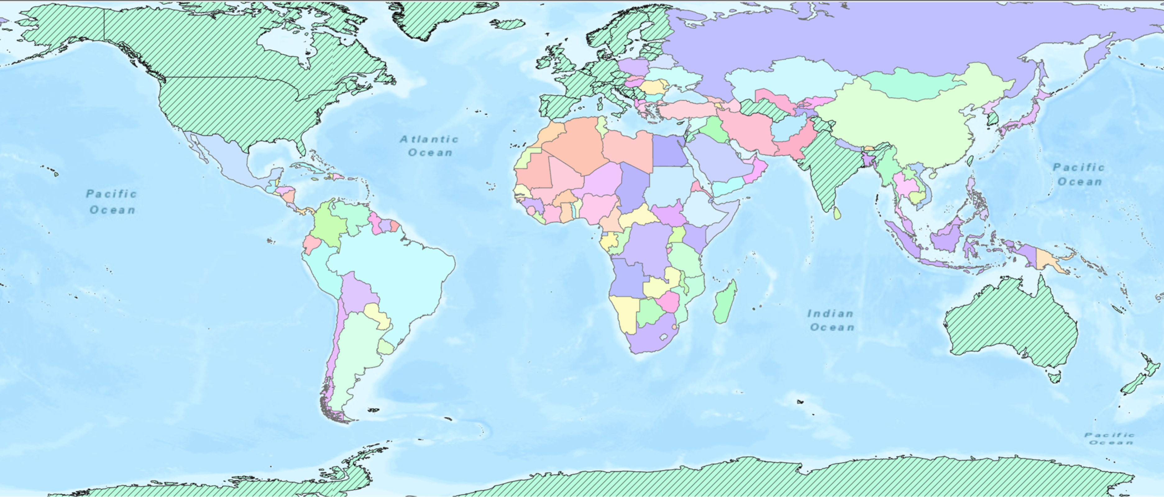

Figure 1. Exercise map results using UN Geospatial Hub Global Boundaries, COD Services API (HDX Companion) sources. March 2022

Exercise Summary

The exercise demonstrates a process of organizing the data sources, reviewing the ArcGIS Pro environment, and generating the outputs through working in the session. Some basic knowledge of working in ArcGIS and scripting in Python is helpful but not required.

Steps:

1. Start ArcGIS Pro:

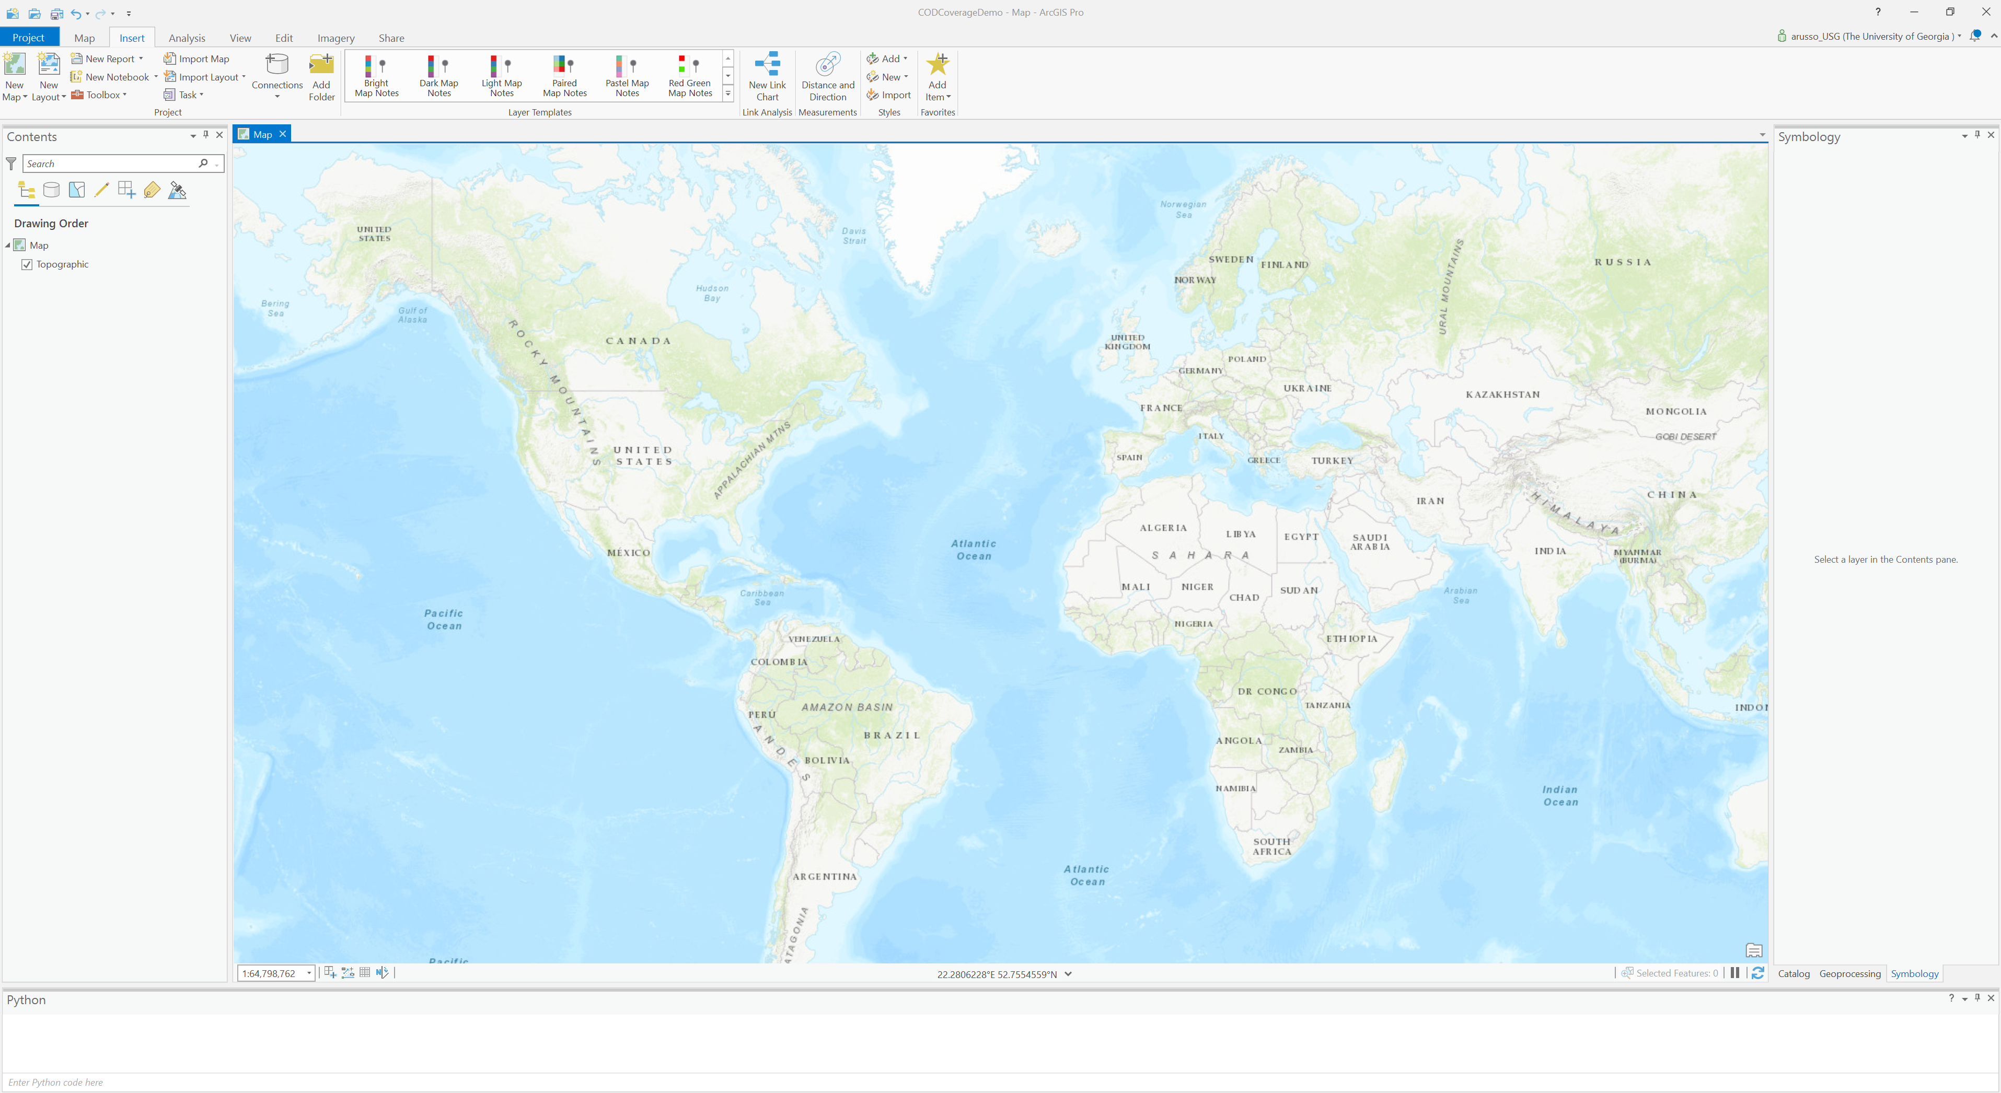

1. Boundary geometry is needed. Several sources are available, one includes the Fieldmaps.io global dataset. Credits to Max Malynowsky and Fieldmaps.io for the work bringing disparate sources together to create a global boundaries layer that may be used for these and similar purposes. Download (<https://data.fieldmaps.io/edge-matched/humanitarian/intl/adm1_polygons.shp.zip>) the Global Edge-Matched Layer. Note that the UN Geospatial Hub is the reference for an UN source that is used for other processes including global edge-matched datasets.
2. Unzip the shapefile and copy the files to your local machine for instance, at C:\WorkSpace.
3. Add the shapefile to the map as a layer. This is typically done through the ArcGIS Pro set of menus and tabs as shown:

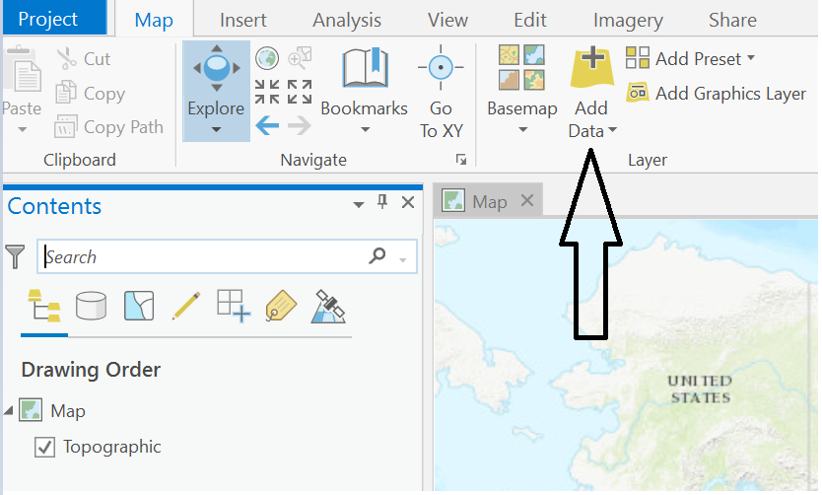

Figure 2. Add Data button that allows to browse files and sources of data to add

Alternatively, you can add the layer to the map using the notebook. Launch the notebook environment directly within the ArcGIS Pro session by clicking on the Insert tab. This shows the New Notebook option.

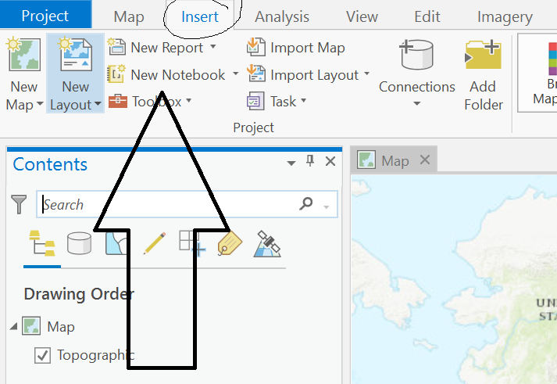

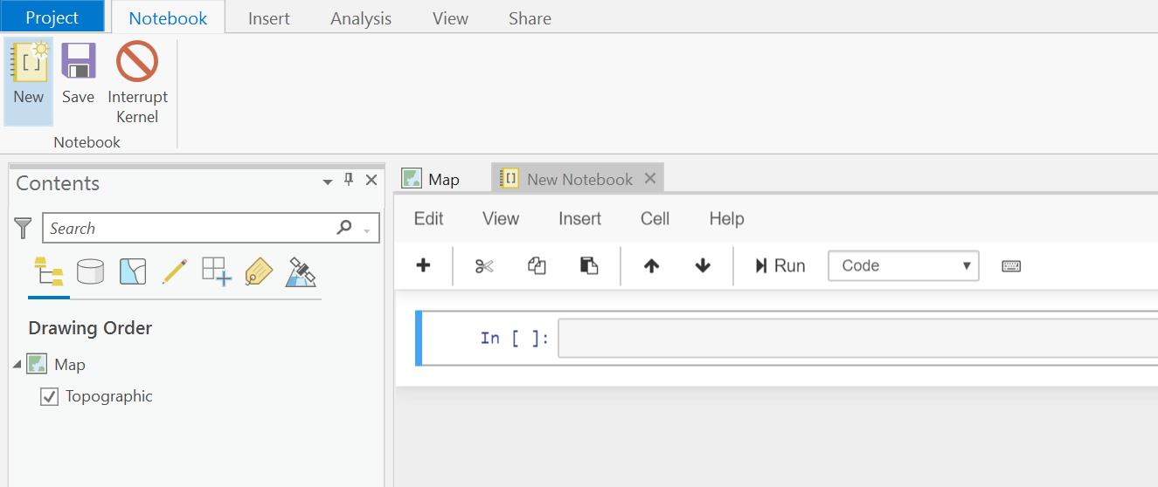

Figure 3.Notebook tab features

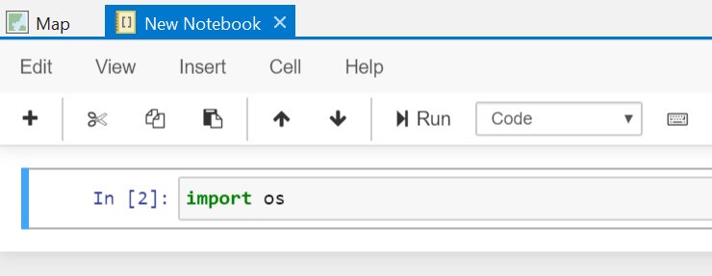

1. If you are new, take a look around. Note the buttons and menu options. If not, proceed to the next step.

If you are new to notebook work, note that the workspace consists of a cell approach to entering statements and blocks of statements. Either the Run button, or Ctrl + Enter on the keyboard will execute the current cell’s statements. The number in brackets, 2 shown in the image above, will increment as the same cell’s code is executed. As you start coding and start to run the statements in the cell, a * may appear to let you know there is work occurring and that is why you don’t see change or results just yet. You can start another cell with the “plus” icon button. This approach allows for more incremental approach to coding, while still allowing for entire scripts to run in one cell. In this first statement example, import os, the operation loads a library that makes other statements for accessing files (like the downloaded shapefile) on the local machine workable. There will be other similar imports through this exercise. In some cases, there may be the need to install packages and then to import their libraries to make them available, however, these should not be needed here. More on installing external libraries are found here: https://pro.arcgis.com/en/pro-app/2.8/arcpy/get-started/work-with-python-packages.htm.

So, in the next few images, more code is introduced with additional statements in the cells to load the global boundaries shapefile that will define the countries for the map geometry in this exercise.

Note in the second cell shown below, that there is a means to make reference to the session and the map default topographic layer.

1. Enter the code in the second cell as shown and run the cell. The output “Topographic” outside the second cell is the results of the cell when executed. In this way, we can see how the layer is accessed. This layer is the default layer for the map and it is also shown in the “Contents” window.

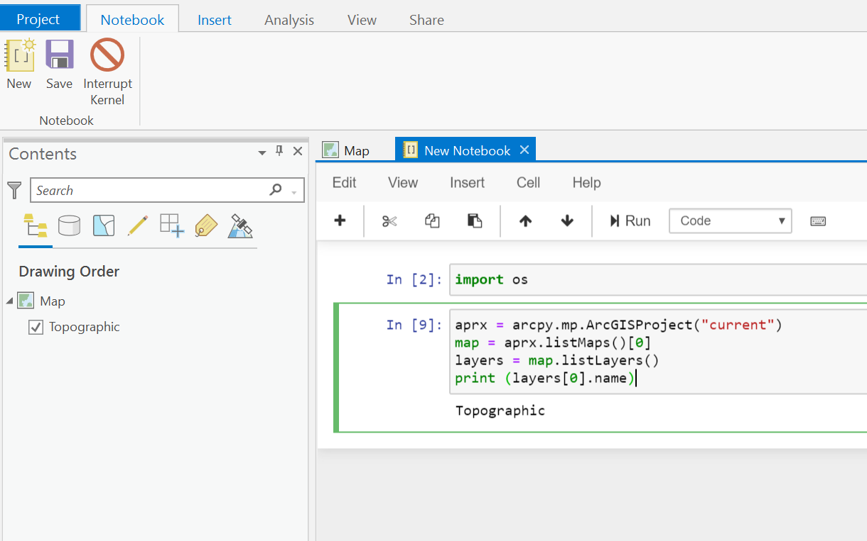

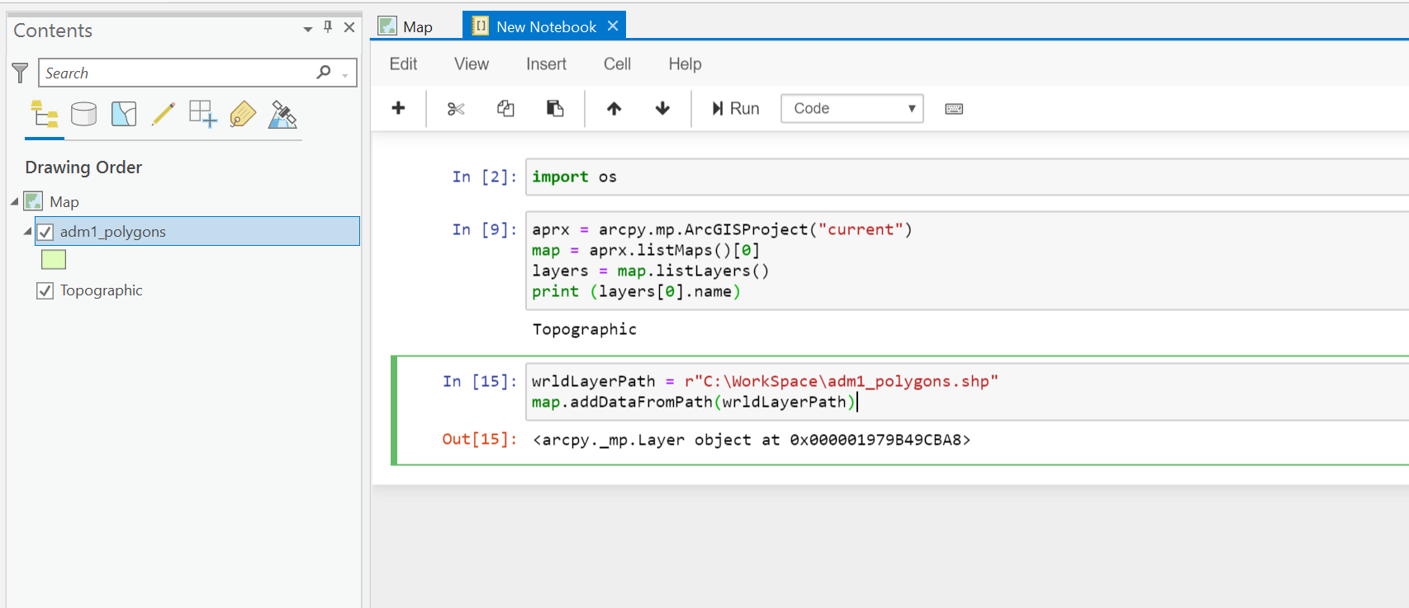

1. The cell that is at position three is the code that loads the boundary layer. Enter it if you are following along and run it.

In a new cell, the COD Services API data may be loaded to show which countries have CODs. The url provided when invoked shows that there is a message that an additional library is needed.

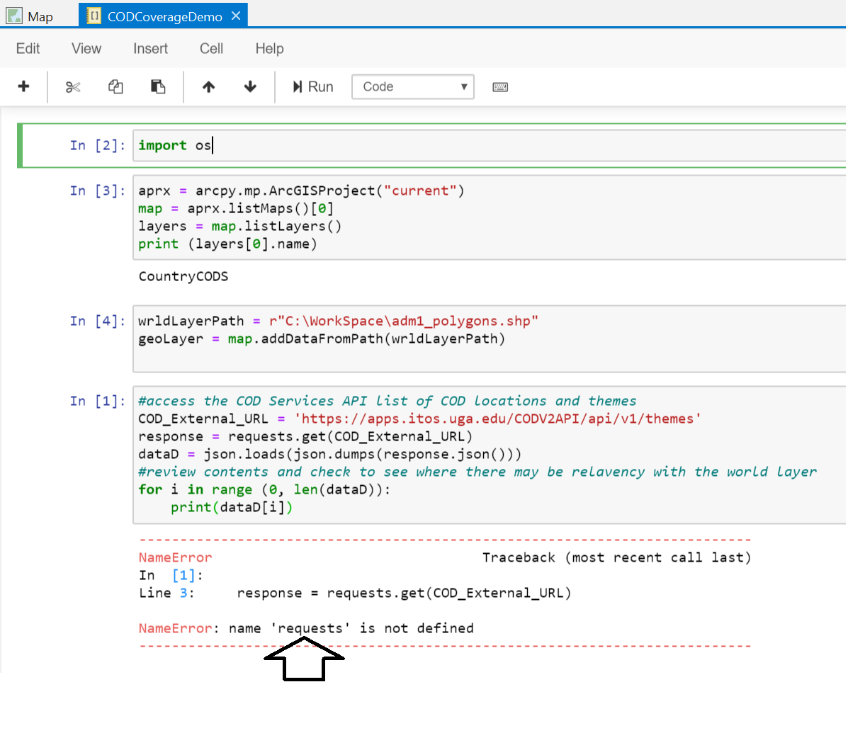

This is where we need another import. Line three shows the requests statement that is resulting in the “NameError” condition. The requests library allows for accessing API data outside the users’s machine’s local network through the protocols. Note that we used the arcpy reference without one. That is because we are within an ArcGIS Pro session. The requests python function is also installed but it is not available to the session, so we will import it and add the line up in the first cell. Remember we have to run that, so enter Ctrl + Enter in the first cell after adding it. You can add import statements anywhere in code, they are typically added in the beginning for readibility and to organize the code flow in a readible fashion.

1. Add the import requests statement and enter the code and run the last cell. The error is no longer encountered:

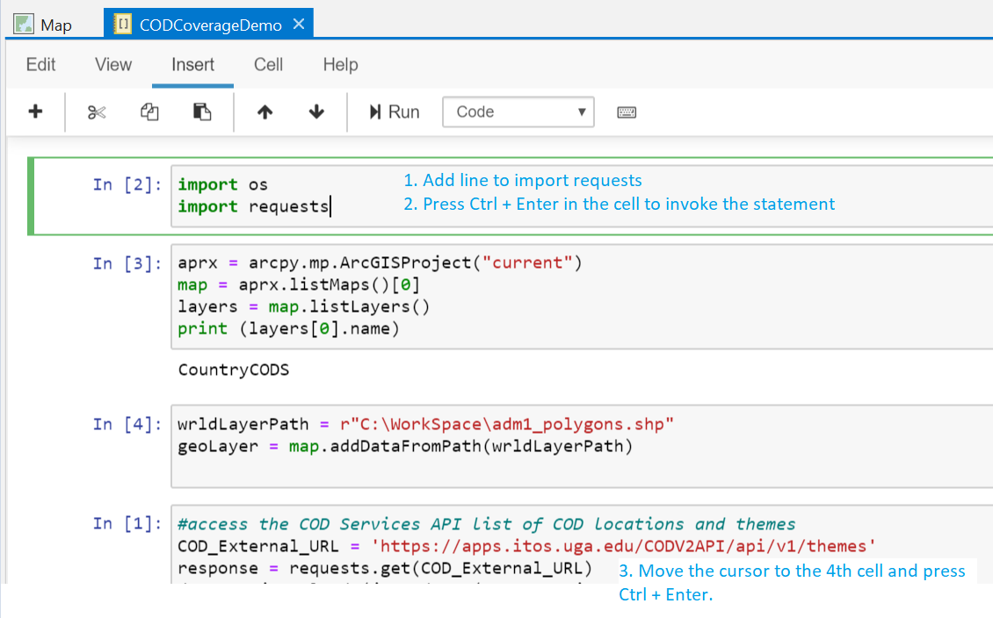

1. Now add a line in the first cell again to import json, run it and add the code to review the output of the COD Services API call. This is shown in the image below. This way we can find where we may use the relevant relatable contents or attributes to show the results on the map. The context for the relationship between the two sources is the 3-character country ISO code. The output shows the 3-character code contents grouped by theme, followed by the count of countries.

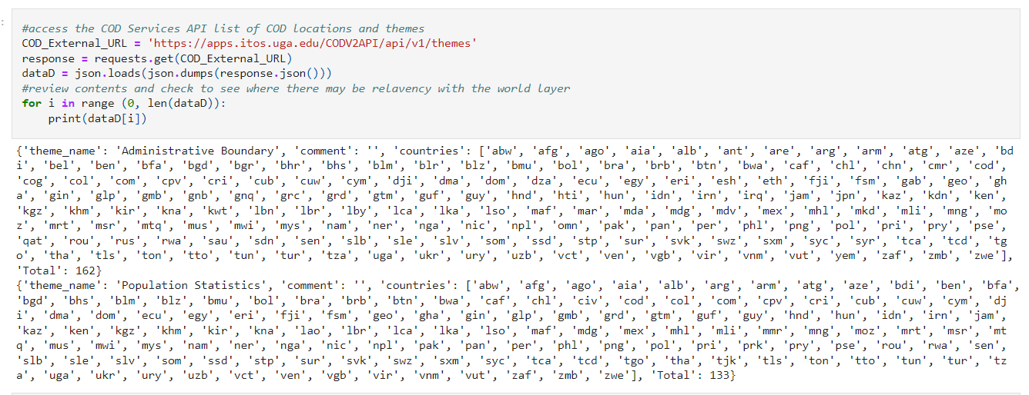

1. Find the common bind attribute. To review the layer table and find the correct attribute to join to, right mouse click on the layer in the map contents to get the context menu, which includes the “Attribute table” command:

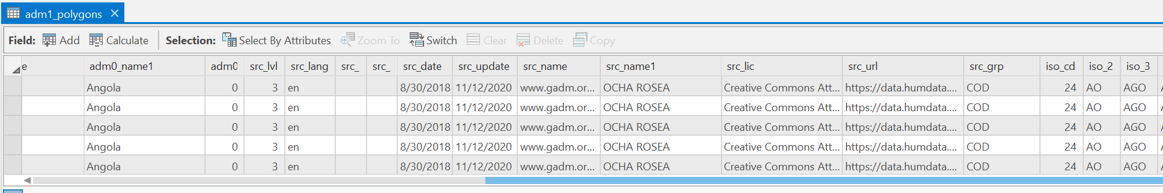

So, comparing results of the COD Services API themes call to the geometry layer, The geometry may be related based on the iso_3 contents, provided the letter case is updated to match. For this first example we are interested in seeing any location for which there is a COD on the map regardless of theme. In the next step, we will arrange the output to have the countries as rows to join to the geometry layer in the map. We will do this using Pandas libraries.

1. Add another import statement to the first cell using the as keyword for standardization purposes:

**Import pandas as pd**

Ctrl + Enter to invoke this.

1. In the last cell add the Pandas statements to arrange the output. There will be a long list now of 3-character iso countries followed by an index instead of two rows by theme: ‘Administrative Boundary’ or ‘Population Statistics’.

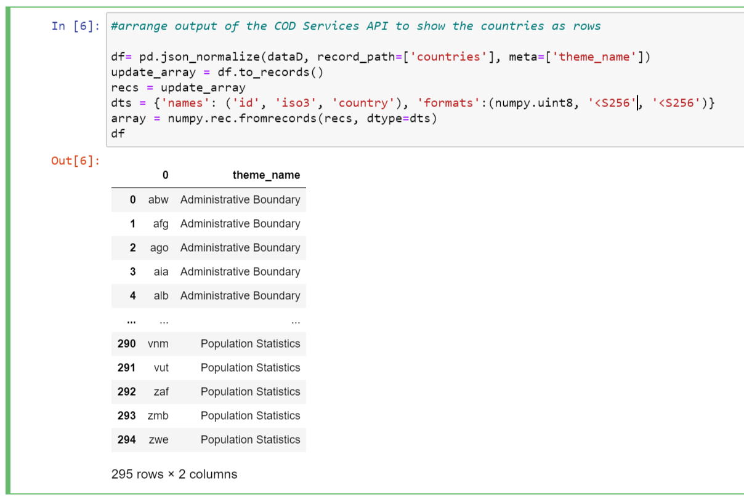

Once the output is upper case, the data can be joined to match up with the geometry in the world boundaries layer and shown on the map.

1. Add another cell, include the code and run with Ctrl + Enter

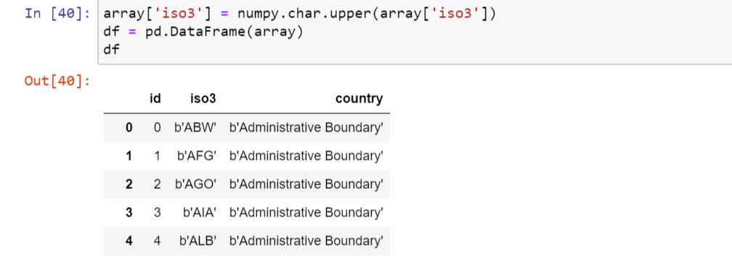

The upper-case output can now be added as a standalone table in the map.

As we progress along the way, we can see how it is useful to work in this Notebook fashion, with groups of cells organizing code in manageable sections, that can be run to examine output.

Note that the output is the complete result set of rows, but the default setting shows just a few so to see all rows, the following statement may be added to the block: pd.set_option(‘max_rows’, None).

Also, the b’ denotes that the output is encoded which may impede matching to the boundary layer. Updating the line in cell 5 allows for decoding of the ISO3 values:

dts = {'names': ('id', 'iso3', 'country'), 'formats':(numpy.uint8, 'U13', '<S256')}

1. In the next cell, enter the code to create the standalone table with organized and formatted contents (array) and join with the geometry layer as shown with the following example:

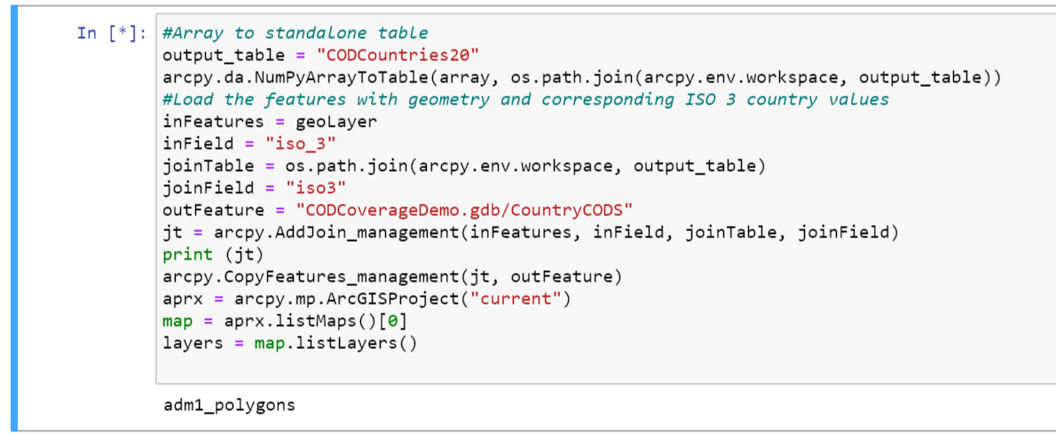

1. Review the attribute table of the layer. Note the new fields are added based on the join.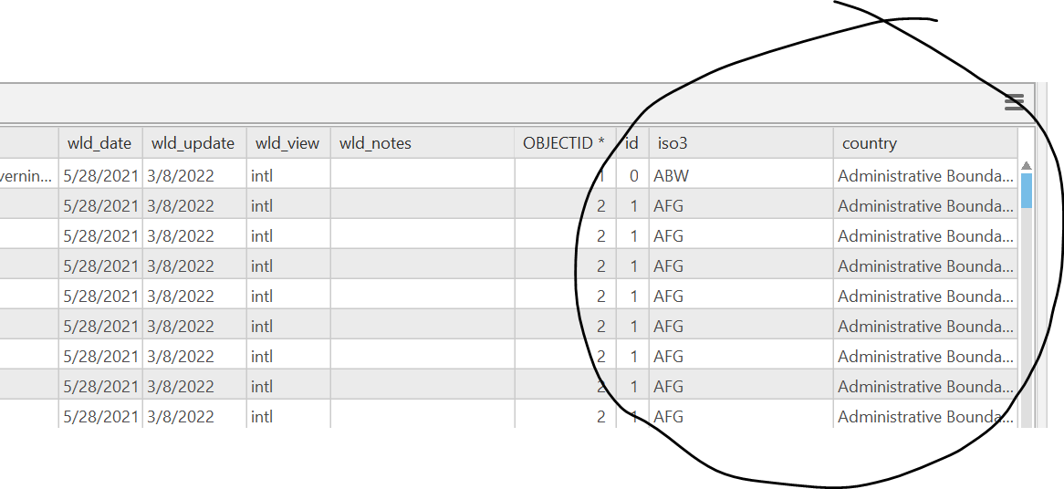

Figure 4. Layer with joined attributes from the Notebook exercise

Also opening the layer table and examining results help verify the results. Scrolling down, we see some features do not have representation of iso3 and are shown as <Null>. Update the map to see more clearly.

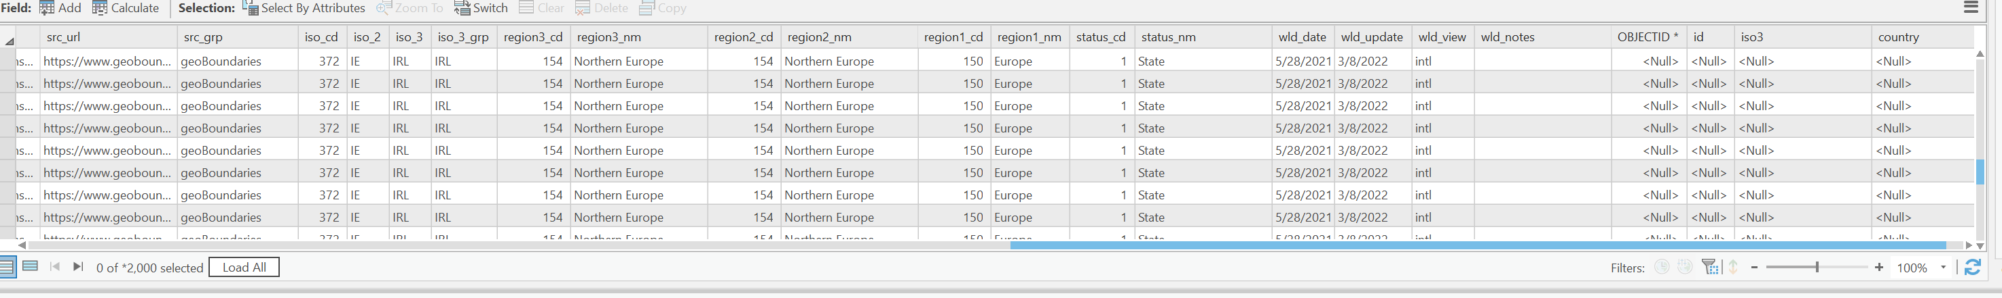

1. Symbolize based on the ISO3 values using the Unique Value Renderer:

Right click on the layer name added from the join in the “Contents” window and select the “Symbolize” option to get the menu to set the symbols based on the iso3 as shown below: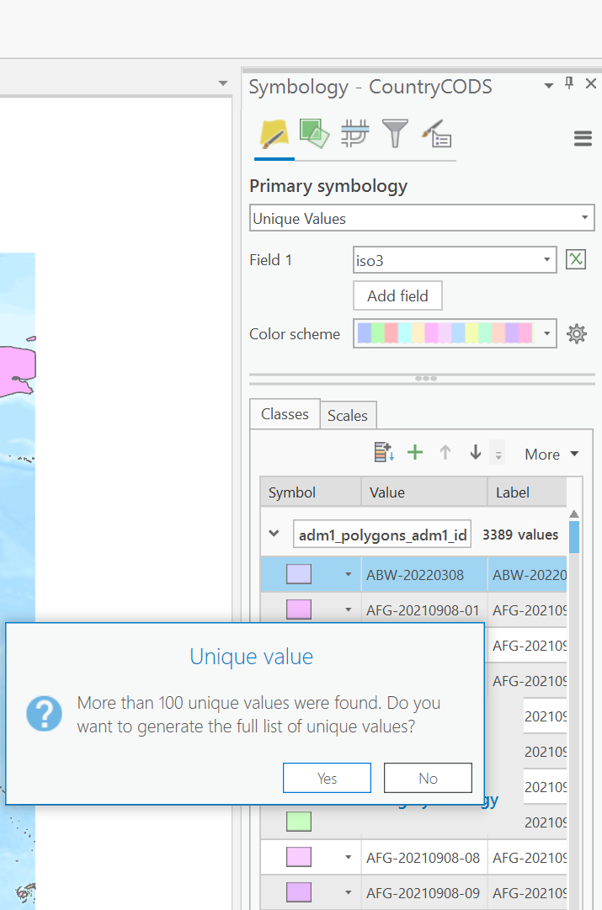

The individual values and symbols may be changed as may be done with the Null values so they are easily differentiated. Double click on the symbol itself to access a menu that has additional choices where patterns or symbols derived from styles that may simulate dimensional textures are available.

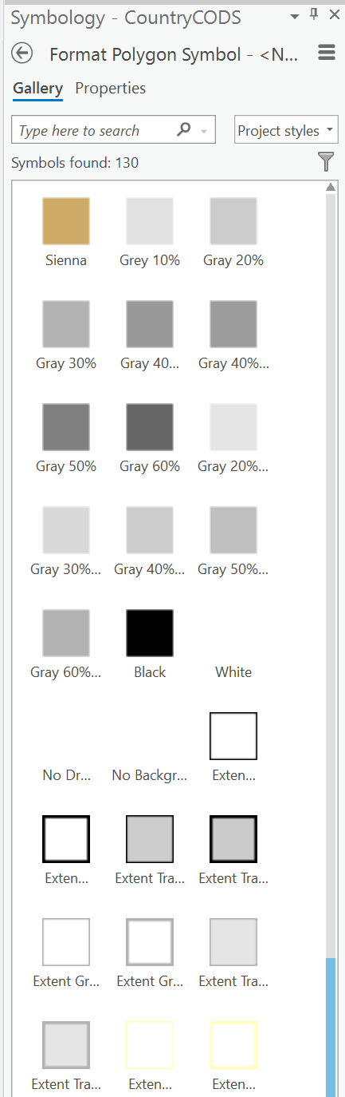

Areas that do not have corresponding values in the COD Services API and for which there are no CODs are null and not matching the geometry. These were updated to show a symbol that is easily differentiated from the matching areas. The symbols render those areas based on the opaque white whereas those areas that match are in pastel. 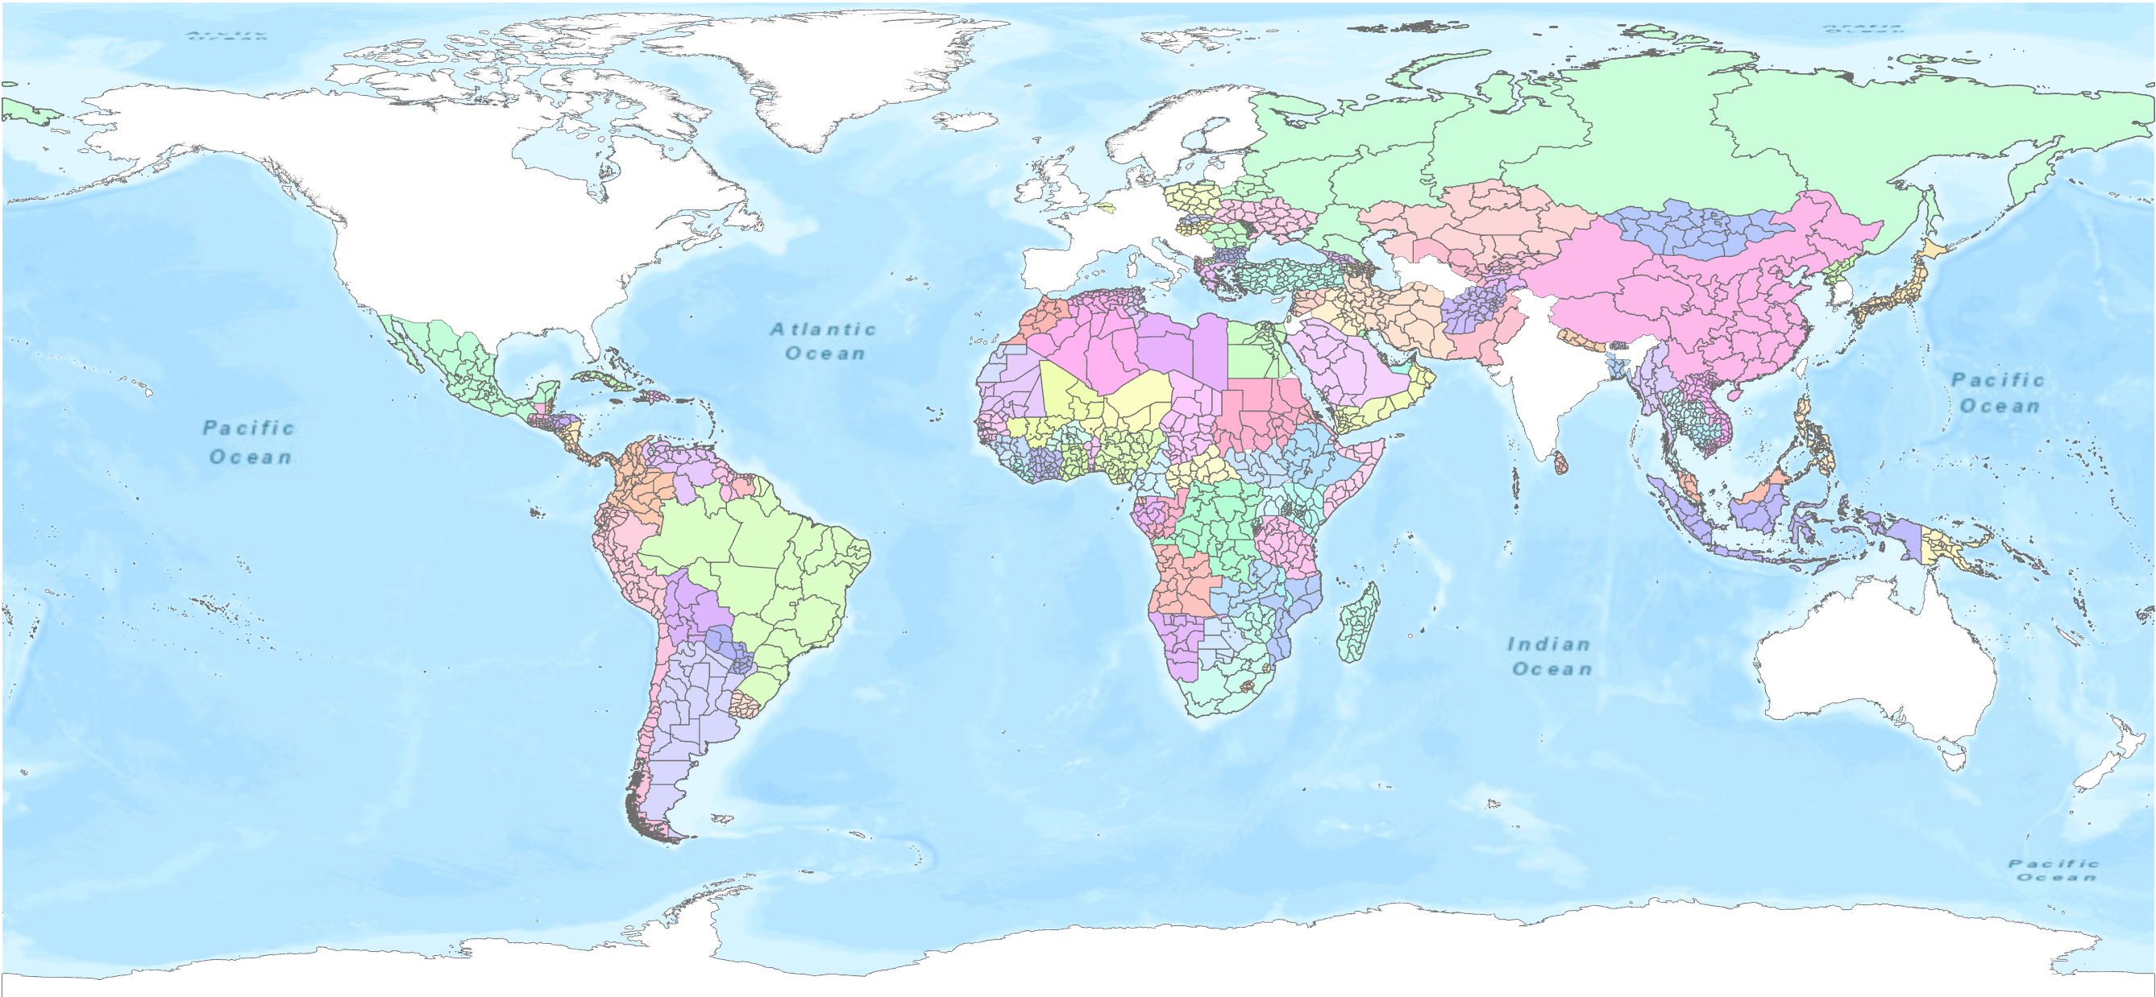

Note that the approach was to use a common ISO-3 value to match the different data sources with slightly different names on the attributes. In this example, the boundary layer is fully representative of the ISO-3 in the COD Services API. There may be other cases that althougth the field may be named the same or similar or the have the same pattern of values, the data are not in the same context, so matching should be done with a review of the sources to ensure the context is the same. For this example the context of ISO-3 in the global boundary layer and the COD Services API is the same so the results can be interpreted as a valid showing of countries with CODs and their locations as of March 2022.

An example of the notebook may be found and downloaded here:

https://github.com/UGA-ITOSHumanitarianGIS/CODV2API/blob/main/Scripts/CODCoverageArcProNotebookDemo.ipynb

So, the notebook approach makes for a flexible means to incorporate the data science environment conventions with the GIS layers. The COD Services API example shows how that this map may be updated with a real time result based on a system call rather than a static dataset.